Plants vs. Zombies 3(50) : Project Overview 2
Module 1: Motion Generation 2
Module 2: Energy Conversion and Transmission 2
Module 3: Safety and Motor Control 2
General Safety Precautions 3
General Project Specification and Individual Expectations 3
Playing Field: 3
Proximity Sensors: 4
Detection of Active Targets: 6
Hard Stops: 6
Limit Switches: 6
Motor: 7
Encoder: 7
Transmission: 7
Craftsmanship: 7
Individual Expectations: 7
Testing and Design Specification 8
Mounting: 8
Initial Position: 8
Testing: 8
Design and Performance Evaluation: 8
Transmission Angle Deviation (20% of Test Results Grade): 8
Weight (30% of Test Results Grade): 8
Performance Score (50% of Test Results Grade): 9
Manufacturing 9
Project Kits and Available Materials 10
Grading and Deliverables 13
Prototype Craftsmanship 13
Gate Review Requirements 14
Final Report 14
Peer Reviews 14

Plants vs. Zombies: 3(50): Project Overview
The goal of this project is to design, build, and test a powered mechanism that will automatically detect targets furthest from the proximity sensors and shine light on their corresponding photosensors to have the targets return. Targets will travel forward on four rails towards the four photosensors and the mechanism must shine light on corresponding photo sensors to send the targets backward. The targets will change direction upon receiving enough light from the LED or hitting the front limit switch (except in round 3, where the target only changes direction from LED activation). The mechanism you develop will use a DC electric motor in a closed loop position control system to move the LED to the desired position and orientation accurately enough to shine light on all four photosensors, and quickly enough to send back targets before they hit the front limit switch.

You are expected to apply the knowledge you will learn in lectures and labs to a model-based design in three modular phases:

Module 1: Motion Generation
You will apply your knowledge of mechanisms to design a mechanism capable of moving the LED to the desired positions and orientations with a single motor. You will use SolidWorks to create a detailed design of the mechanism and you will use ADAMS to create a dynamic model of the mechanism and determine the validity of the dynamic response by comparing the requirements of the desired motion (i.e., maximal power) with the provided motor. The designed mechanism must have a low moment of inertia to ensure a fast dynamic response.

*PLEASE NOTE: Past students have regretted not spending more time optimizing design components in module 1, as small mistakes made here can lead to large performance issues in the later modules. Transmission angle deviation is a critical metric to performance.

Module 2: Energy Conversion and Transmission
You will apply your knowledge of motors and transmissions to design a transmission that, in combination with the supplied motor, minimizes travel time while meeting speed and torque requirements. The transmission will be designed using an “Inertia Matching” method in which the reflected inertia of the motor is matched with the inertia of the load, thereby theoretically ensuring an optimal dynamic response. In addition, the transmission must have a low moment of inertia and an appropriate stiffness to provide a good dynamic response. Finally, the transmission ratio must result in a high enough resolution at the output, so that the motor can repeatedly position the LED accurately.

Module 3: Safety and Motor Control
You will apply your knowledge of sensors and controllers to safely move your mechanism into the desired position and orientation in time to shine light on photosensors as their targets become active. This will be achieved using an Arduino microcontroller board, limit switch, and toggle switch.

The purpose of this project is to reinforce the material learned in the lectures and to provide a realistic experience in model-based design. Details of each step of the project are provided in the design labs and lectures as the semester moves along. Students are required to build the prototype in the ME student machine shop using the materials provided (see below). Note that work in the machine shop cannot begin until each group member has completed the required machine shop training.

The project is set up as a system design task that is decomposed into the major subsystems of motion generation (mechanism), energy conversion/transmission (motor/transmission), and motor control (sensors and controller). We will design using model-based methods and will fabricate and test each integrated subsystem as we build up the full device. At each stage there will be Gate Reviews (checkpoints in the form of written reports and presentations) that provide the necessary feedback to your GSI in order to assess progress. For example, teams must pass a Gate Review with their GSI prior to fabrication in order to ensure that the manufacturing plans are reasonable and safe. These written reports are designed to be portions of the final report, such that the effort to create the final report becomes reasonable. A report template will be provided to guide students in the length and important content in each section. The reports should be well written and contain good writing flow. Deadlines are assigned to deliverables, and it is highly recommended that students try to complete the activity when possible some time before the checkpoint date in order to provide a buffer if things do not proceed as expected.

General Safety Precautions
- When testing out your system, do not wear long sleeves, jewelry, or loose-fitting clothing.
- Long hair should be pinned up.
- Be aware that if the power to the motor or controller (see below) is shut off and then restored, the controller will continue to run the program it was previously running.
- Keep parts of your body out of the path of motion of the mechanism.
- Do not touch the spinning shaft of the motor.
- Connect your motor to the power supply only under GSI supervision.
- When testing out your motor, always start with the voltage at the lowest possible level, and gradually increase it until you can get the motor to move.
- Expect the unexpected.

General Project Specification and Individual Expectations

Playing Field:
A top-down view of the playing field is shown in Figure 1. It is composed of four photosensors (blue) located at the end of four rails (orange). (GL205 Series Photoresistors by Futurlec, part #: PHOTOCELL24.) Each photosensor affects the zombie on the rail it is at the end of. The stands of the leftmost and rightmost photosensor are printed with a cone around the light receptor severely limiting the angle at which you can successfully shine light on the photosensor. The rightmost photosensor is angled towards a mirror located along the right wall of the playing field (purple). The mirror allows you to shine light at an angle to hit the photosensor which will not be blocked by the cone. All dimensions given in this figure are approximate.

You will attach your mechanism to the mounting holes at the bottom of the playing field (green). A pattern of mounting holes for 3/8”-16 screws is provided. For better alignment of your mechanism to the playing field, dowel holes are also provided.

To simulate a real-world design situation, a CAD solid model of the playing field is not provided. You are expected to take your own measurements on the physical playing field. Critical dimensions are shown in Figure 1 but should be considered approximate. The playing field will be available for you to take measurements in the X50 Assembly Room (1510 GGB). This room is accessible using your M-Card. Details for getting access to the X50 Assembly Room will be provided in a Canvas announcement.
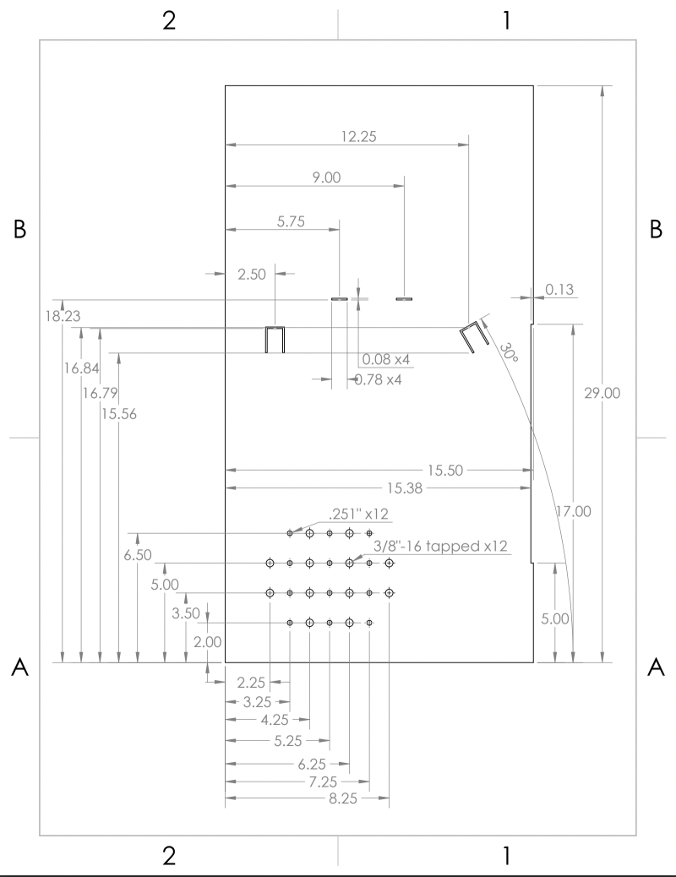
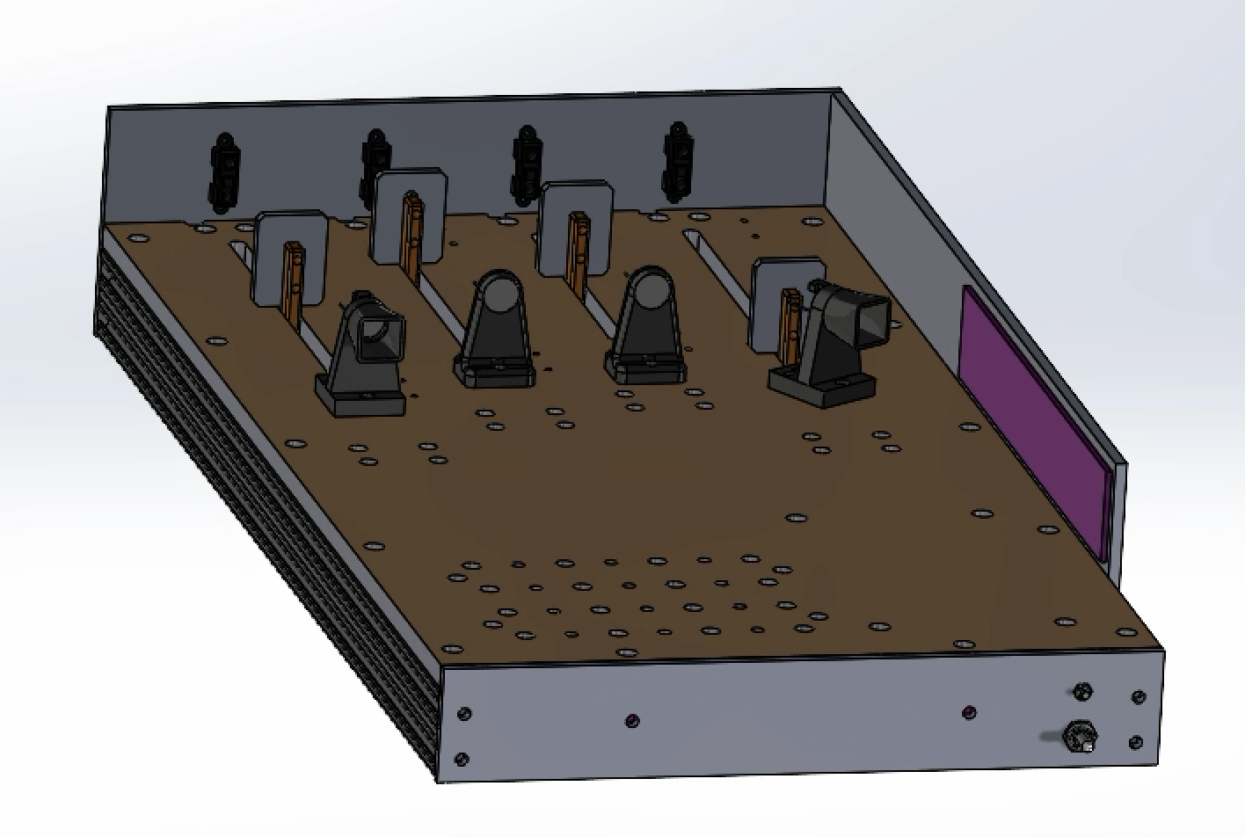
Figure 2. Playing Field, Perspective view

Proximity Sensors:
The playing field will have four proximity sensors mounted on the back wall of the mechanism, pointing parallel to the directions of the zombie travel rails. The proximity sensors will be connected to your mechanism’s Arduino microcontroller and will sense the current location of each target to indicate which target is closest to the photosensors. The sensors are identical, but the rail lengths are not the same. Because distance is only relative to each rail, it is okay if the proximity sensors have different readings when the targets are in the same location. When your mechanism senses it needs to knock back a target, it should move to the appropriate position to shine your team’s high-powered LED on the target’s corresponding photosensor. The target will stop moving forward when light is shined on the corresponding photosensor and eventually move backward after a specified amount of time has passed (a board setting not provided). Detection of Closest Targets:
Your mechanism needs to detect where a target is on the rail as well, the direction the target is traveling, and the location of the corresponding photosensor on the playing field using the four proximity sensors mounted to the playing field at the start of each of the rails. Based on the closest target moving forward, your mechanism should maneuver to shine light on the photosensor corresponding to the closest target to send it moving backwards.

Hard Stops:
The mechanism should come to a hard stop (also known as a positive stop) on both ends of its desired range of motion. In other words, one part of the mechanism should contact a hard detail, to provide a repeatable limit to the motion and prevent overshoot. Each team will design and build their own hard stops. The hard stops must be mounted to your ground link, explained in “mechanism connection” below (not installed as separate pieces on the playing field) so that only the ground link needs to be bolted and unbolted to the playing field.

Limit Switches:
One limit switch is provided and could be used to calibrate the limits of the mechanism’s range of motion. The limit switch detects the presence of the mechanism by direct physical contact with a linkage component. When contact is made, a lever on the limit switch activates, sending a signal to the controller that the linkage is at either limit of its range of motion.

Motor:
Each team will receive one DC permanent magnet motor. All motion of the mechanism must be driven by this motor. For this project, the motor will run at 10V. Although this motor is capable of operation at higher voltages, do not connect the motor to voltages higher than 10V. This constraint is imposed to limit the torque and speed of the motor. For testing and measurement, a power supply set to 10V is provided, but lower voltages can be used if desired. Teams must mount their motor to their ground link, and plan space for the motor and transmission (gears, pulleys, chains, or other methods) in their design.

Encoder:
This gearmotor given is integrated with a 30:1 metal gearbox and an integrated quadrature encoder that provides a resolution of 64 counts per revolution of the motor shaft, which corresponds to 1920 counts per revolution of the gearbox’s output shaft. You will use the encoder and the limit switches to position your LED.

Transmission:
To achieve the desired performance of the mechanism, you will have to design and build a transmission. The transmission can consist of a timing belt and pulleys, gears, a chain and sprockets, or other mechanical elements. You will have to determine the transmission ratio based on an “inertia matching” technique that will be taught in class. At the same time, the transmission ratio should not produce poor resolution at the output. Before finalizing the transmission design, make sure you have taken adequate steps to minimize friction in your mechanism.

Craftsmanship:
It is important that this mechanism is well-made and can reliably operate many cycles. The device should be robust, efficient, and predictable. Play in joints, friction, and unnecessary mass must be kept to the absolute minimum. Proper materials should be utilized (e.g., do not use duct tape). Your machine should have a professional look. Do not paint your mechanism – we want to see the machined parts and their surfaces directly. The same holds for your Arduino code. Make sure it is readable for others. See Section 8 below for further details on craftsmanship.

Individual Expectations:

Each member of the team is expected to develop one mechanism concept for the “Linkage Design and Conceptualization” stage. This will provide the team more options for the final design and allow each student to have experience with SolidWorks and ADAMS. We encourage each student to seek assistance from their fellow team members as well as from the GSIs during design. The division of the remaining tasks and report writing is up to the team. However, each member must contribute actively to the manufacturing process.
To simulate a more realistic design scenario, we will continue to distribute information throughout the semester. Although this may be frustrating, this is normal in the design process. We encourage you to lay out your calculations and your drawings on the computer (spreadsheets, CAD system, etc.) so that you can make changes quickly and easily.

Testing and Design Specification

Mounting:
For Final Testing, you will be given 5 minutes max to set up your project and 5 minutes max to take it down from the playing field. Set up consists of attaching your project to the playing field and connecting all electronics.

Initial Position Testing:
After your linkage is securely mounted to the playing field, a GSI will move your linkage to a random starting position within its range of motion. Your linkage will be required to move to contact the limit switch to calibrate the encoder count. Students will write calibration instructions into the controller code to achieve this function. If your linkage cannot be set to a random initial position by a GSI (and your team dictates the initial position instead), a 100-point penalty will be assessed to that testing trial.

Design and Performance Evaluation:
The performance of the mechanism in these tests will be evaluated based on the following specifications, described in detail below and organized in Table 1.

Transmission Angle Deviation (20% of Test Results Grade):
The transmission angle is defined as the angle between the coupler and output link for a four-bar-linkage. The transmission angle is a measure of how effectively force is being transferred between the coupler and output link and the ideal value is 90°. As a rule of thumb, the transmission angle should always lie between 30° and 150° to prevent undesirable linkage behavior. The transmission angle deviation of the mechanism is defined as the absolute value of the transmission angle of the mechanism minus the ideal transmission angle of 90° in the useful range of the mechanism (i.e. between the hard stops). Mathematically, this can be written as:

Transmission Angle Deviation = |Transmission Angle - 90°|

The ideal deviation is 0°. For grading purposes, the average of the transmission angle deviations in each target position is considered.

Weight (30% of Test Results Grade):
The weight of the moving parts of the mechanism should be as small as possible.

We will measure the weight of: the input link, follower link, coupler link, flashlight, flashlight mounting hardware, rotational joint hardware (including those on the ground plate), transmission hardware attached to the input link, and any other parts of your mechanism that move.

We will not weigh: the Arduino, H bridge, breadboard, electronics mounting, ground plate, hardstops, motor, and other static components of the mechanism.

Performance Score (50% of Test Results Grade):
The performance score of the mechanism increases each time the mechanism shines light on a photosensor, causing the target to move backwards. The score will not increase if the target changes to move backwards by hitting the front limit switch or if the mechanism is held against the back limit switch (by keeping the light on the same photosensor). The score will also not increase if light is shined on a target already moving backwards.

Performance is measured over three rounds. For the first round, the targets will move forward and will be sent backwards either by activation of the photosensor or by hitting the front limit switch. Round 1 will last 40 seconds, and teams will earn 1 point for every target successfully knocked back. For the second round, the targets will move faster than in the previous round but will be sent backwards in the same way. Round 2 will last 40 seconds, and teams will earn 1 point for every target successfully knocked backwards. In the third round, the targets can only be sent backwards by activation of the photosensor. The round lasts until one of the targets hits the front limit switch. The target speed will increase with time. In the third round, teams will earn 1 point for every target successfully knocked back.

Teams are allowed to touch and recalibrate their linkage between rounds but not during a round. If a team needs to touch their mechanism during a round, there will be a 1 point deduction to the team’s total score for every touch required. The performance score should be maximized.

Table 1: Evaluation criteria.
Specification | Description | Target | % of Grade | Method of Measurement
Transmission Angle Deviation | |Transmission Angle - 90°|  (average of all five targets) | 0° | 20 | Machinist’s Protractor
Weight |  | Minimize | 30 | Scale
Performance Score | Based on number of targets dropped and amount of light on targets | Maximize | 50 | Playing Field

Table 2: Performance Scoring.
Action | Measurement | Scoring
Retreat Target- R1 | Number of targets successfully sent back in R1 | Measurement x 1
Retreat Target- R2 | Number of targets successfully sent back in R2 | Measurement x 1
Retreat Target- R3 | Number of targets successfully sent back in R3 | Measurement x 1

Manufacturing
The teams may use the G. G. Brown machine shop and assembly area as well as the X50 mechatronics lab for this project. Work in the machine shop cannot begin until each group member has completed the required shop training outlined in the syllabus. Before you fabricate any parts in the machine shop, you must follow the procedure below:

- Create detailed drawings and manufacturing plans for each part, including all dimensions and tolerances.
- The drawings and manufacturing plans are reviewed and approved by the GSI.
- Finally, the drawings and manufacturing plans must be approved by the machine shop.

Note: Projects will be stored in the cabinets of the X50 assembly area.

Project Kits and Available Materials
The following list of materials will be available for the fabrication of your prototype. Materials outside of the list and not found in the shop must be approved by your GSI.

Note: All dimensions below are nominal and may have some variation; if critical you should measure the stock material.

Table 3: Kit Items
Item Description kno | Part # | Supplier | Qty per team
Aluminum Plate, 1/4" x 12" x 18" | 21430300 | Alro Steel | 1
Aluminum Angle, 2.5" x 2" x 1/4" thick, 6" long | Custom | Alro Steel | 1
Aluminum round stock, 1” Diameter, 12” Long | Custom | Alro Steel | 1
SAE 841 Sleeve Bushing for 1/4" Shaft Dia., 1/4" Lg. | 6391K126 | McMaster-Carr | 10
Needle Thrust Bearing, Bore .250 | 4XFL8 | Grainger | 4
30:1 Metal Gearmotor 37Dx68L mm with 64 CPR Encoder | 4752 | Pololu | 1
Bracket for 37D mm Metal Gearmotors (w/ 9 M3 screws) | 1995 | Pololu | 1
Snap Action Switch (a.k.a. limit switch, microswitch) | 187733 | Jameco | 1
Toggle Switch Single Pole Single Throw (On-Off) | 76523 | Jameco | 1
400-point Breadboard | 351 | Pololu | 1
Arduino Uno microcontroller board | DEV-09950 | Sparkfun | 1
H-bridge (L298 Motor Driver -- preassembled) | K CMD | Solarbotics | 1
Mounting Board for Arduino, H-bridge, and breadboard | Custom | N/A | 1
Infrared Proximity Sensor, Short Range | GP2Y0A41SK0F | Sparkfun | 1
AR-100 LED Flashlight | B01CB2ZTYQ | AR happy | 1

Table 4: Available in the machine shop or X50 assembly area (1510 GGBL)
Item Description | Part # | Supplier
Nylon Unthreaded Spacers, 5/8" OD, ½" Length, for ¼" ID | 94639A694 | McMaster-Carr
Shoulder Screw, ¼" Diameter x ½" Shoulder, 10-24 Thread | 91259A537 | McMaster-Carr
(Other lengths of shoulder screws will also be available)
Oil-Embedded Thrust Bearing (Washer) for 1/4" Shaft Dia., 5/8" OD, 1/16" Thk. | 5906K531 | McMaster-Carr
Nylon Locknut, 10-24 Thread Size | 90631A011 | McMaster-Carr
Socket Head Cap Screw, 3/8"-16 Thread, 2" Length | 91251A632 | McMaster-Carr
Socket Head Cap Screw, 3/8"-16 Thread, 2-½" Length | 91251A634 | McMaster-Carr
Socket Head Cap Screw, 3/8"-16 Thread, 3" Length | 91251A636 | McMaster-Carr
Socket Head Cap Screw, 3/8"-16 Thread, 3-½" Length | 91251A638 | McMaster-Carr
Socket Head Cap Screw, 3/8"-16 Thread, 4" Length | 91251A640 | McMaster-Carr
Washers, 3/8" | 91083A031 | McMaster-Carr
Washers (3/8" hi-collar spring lock) | 91104A031 | McMaster-Carr
Socket Head Cap Screw, 2-56 Thread, ½” Length | 91251A081 | McMaster-Carr
1/4" ground and polished steel dowel pins, 1” Length | 98381A542 | McMaster-Carr
1/4" ground and polished steel dowel pins, 1-½” Length | 98381A546 | McMaster-Carr
1/8” ground and polished steel dowel pins, ½” Length | 98381A471 | McMaster-Carr
Spring Pins | Various
Nylon Cable Tie, 3" Long, 10 lb. Break Strength, White | 7130K101 | McMaster-Carr
Nylon Cable Tie, 7-½" Long, 50 lb. Break Strength, White | 7130K19 | McMaster-Carr

Available in the X50 Assembly Room and Mechatronics Lab:
- Assembly tools
- Cutting and finishing tools
- Soldering irons and supplies
- Various adhesives

In addition to the kits, each team may spend up to $100 on project supplies that they have reviewed with their GSI. Teams are encouraged to use part of their $100 discretionary funding to purchase parts for the transmission (i.e. timing belts and plastic pulleys, or metal gears) to reduce the speed and increase the torque from the motor to the linkage. These parts should be ordered no later than 2 days after Gate Review 2 in order to meet the project deadlines. Note that you can often get small parts quickly at a local hardware store, such as Stadium Hardware or Carpenter Brothers in Ann Arbor, and materials from Alro Metals on South Industrial Highway in Ann Arbor.

When 3D printing parts, you will not need to purchase material. You will be using the printers in the Dude or Machine Shop and will be charged a flat rate of $5 per printing session. This $5 fee is not charged by the staff; however, you must add this $5/session to your bill of materials. You must subtract it from your $100 budget.

Teams must keep their original receipts and fill out a petty cash form before the last day of classes in order to get reimbursed. Please designate one team member to handle all finances and submit only one reimbursement form (with original receipts attached) with the instructor’s signature.

Note: Any donated components (for instance, scrap pieces from the machine shop) must also be approved by a GSI.
Note: Donated component values will be included in the team spending limit of $100. See McMaster.com or another website to assess the value of donated components. (For some small parts, there is a minimum purchase quantity. In these cases, you should only count the cost of the parts that you actually use.)
Note: Bartering among groups with standard kit components is permitted.
Note: Shipping cost is included in the $100 budget.

Grading and Deliverables
The project grade will be divided into the following:

30% Final Report
10% Design Report #1
15% Design Report #2
25% Test Results
20% Prototype Craftsmanship - Overall design, quality of workmanship, surface finish, tolerance and fit, noise level, size, aesthetics, etc.

Note: The main purpose of Gate Review 1 and 2 is to provide teams with feedback from their GSI for the final project, final report, and testing.
Note: All team project work will be documented via shared Google Drive folders and Google Docs. More information regarding the team folders and submitting reports will be provided as the semester progresses.

Prototype Craftsmanship
Craftsmanship is very important. It can affect the performance, safety, and appeal of your machine. You should be diligent in your planning and execution of your manufacturing and assembly of your system. Each student is expected to machine at least one part. Everyone is responsible for the end product, and thus the full system will be graded as a group – so make sure to help out each other. When making your system, observe the following guidelines:

- Safety: Ensure that you have filed all sharp edges so there are no burrs. (We will do a bloody finger test). Threads on bolts should not protrude out more than 1.5 times the bolt diameter. When possible, countersink your holes so the fasteners do not protrude. Try to avoid creating pinch points when possible.
- Aligned: Make sure that the parts are in alignment with each other.
- Sturdy: Minimize the play between your parts. When designing your mounts, allow for adjustment (especially if using a timing belt system) by using slotted holes and/or fitting spacers. If there is not enough tension in the timing belt, it could jump teeth on the pulleys.
- Well-designed and assembled: Think about how you are going to put the parts together. Think about how to get the screwdriver in to tighten screws – will it fit between the parts that you have already assembled? How accessible are the parts that may need to be adjusted?
- Well-machined: Make sure when machining that you end with a good surface finish – this will help to reduce friction and make your system work better and closer to prediction.
- Aesthetically pleasing: Make your system look professional. Don’t use materials like duct tape or excessive amounts of glue.
- Spacers: Do not use stacked washers as spacers; instead, use a single piece of material that you have machined to the proper dimension.
- Arduino Code: Write readable code. Structure it well, indent nested loops and functions, and provide comments for everything you do.

Gate Review Requirements
Separate documents specifying the requirements for each Gate Review will be distributed after teams are formed. These documents will detail what content is required for the Design Report associated with each Gate Review. A template will be provided to guide students in the length and important content in each section.

Final Report
Refer to the course schedule for the due date of the Final Report. A report template will be provided to guide students in the length and important content in each section. The Gate Reviews and Lab Assignments should make a significant contribution to the Final Report, but the Final Report should still be well written and contain good writing flow. Be sure to take any feedback on the design reports from the GSIs into account when writing the Final Report.

The Final Report is worth 30% of the project grade, and the grammar and formatting of the report counts for an additional 10% of the project grade.

Peer Reviews
All students will complete a peer review at two stages during the project. The peer reviews are confidential. Students must review all their team members including themselves. A form with more details will be provided later in the semester. The peer reviews will be reflected in the final course grade for each student. (Refer to the grading section of the syllabus.) If you do not turn in a peer review, you will receive a zero for your peer review score.

These scores should represent the following key aspects of teamwork:

- Professionalism: To what extent did a member take ownership of the project? Did they show the necessary initiative or leadership in certain aspects of the project? What was their level of communication with the rest of the team? Did they stay in sync with all team decisions? Did they keep everyone else in the team informed about their decisions? Did they attend all team meetings? If a member shows a lot of individual initiative, but does not involve other team members in key decisions, or intentionally leaves out one or more members in the project implementation, that should be considered negatively in assigning the Peer Review score for this individual.
- Work Quantity: You have to take stock of all the work that was involved during a certain grading component of the project (Gate Review 1, Gate Review 2, or Final), and determine if a particular member carried a fair share of the workload. Did an individual simply do what they were asked to do? Or did they seek the appropriate project tasks on their own, without being asked by others repeatedly? This should be evaluated based on the quantity of results produced, rather than simply the amount of time or effort expended by an individual to produce results.
- Work Quality: Was the member thorough and reliable in the work he/she performed? This often is a reflection of whether the member took ownership of a task and pursued it with passion to a degree of perfection, so that other team members did not have to come in and fix/redo things repeatedly. If the member took charge or was assigned the responsibility to finish a task, how much could the team trust that the task would be done to everyone’s satisfaction on time?

